Summary of References

1.28.25

Glycemic Control

1. **American Diabetes Association. (2025). 16. Diabetes care in the hospital: Standards of care in diabetes—2025. Diabetes Care, 48(Supplement 1), S321–S326. https://doi.org/10.2337/dc25-S016**

**Intro**: Among hospitalized individuals, hyperglycemia, hypoglycemia, and glucose variability are associated with adverse outcomes, including increased morbidity and mortality. Identification and careful management of people with diabetes and dysglycemia during hospitalization has direct and immediate benefits. Diabetes management in the inpatient setting is facilitated by identification and treatment of hyperglycemia prior to elective procedures, a dedicated inpatient diabetes management service applying validated standards of care, and a proactive transition plan for outpatient diabetes care with timely scheduled follow-up appointments. These steps can improve outcomes, shorten hospital stays, and reduce the need for readmission and emergency department visits.

Twelve recommendations for perioperative care, including risk assessment, perioperative HbA1c goals, blood glucose goals perioperatively, insulin administration perioperatively, etc.

1. **Bhattacharya S, Kalra S, Kapoor N, Singla R, Dutta D, Aggarwal S, Khandelwal D, Surana V, Dhingra A, Kantroo V, Chittawar S, Deka N, Bindal V, Dutta P. Expert opinion on the preoperative medical optimization of adults with diabetes undergoing metabolic surgery. World J Diabetes. 2021 Oct 15;12(10):1587-1621. doi: 10.4239/wjd.v12.i10.1587. PMID: 34754367; PMCID: PMC8554368.**

**Abstract**: Diabetes mellitus (DM) and obesity are interrelated in a complex manner, and their coexistence predisposes patients to a plethora of medical problems. Metabolic surgery has evolved as a promising therapeutic option for both conditions. It is recommended that patients, particularly those of Asian origin, maintain a lower body mass index threshold in the presence of uncontrolled DM. However, several comorbidities often accompany these chronic diseases and need to be addressed for successful surgical outcome. Laparoscopic Roux-en-Y gastric bypass (RYGB) and laparoscopic sleeve gastrectomy (LSG) are the most commonly used bariatric procedures worldwide. The bariatric benefits of RYGB and LSG are similar, but emerging evidence indicates that RYGB is more effective than LSG in improving glycemic control and induces higher rates of long-term DM remission. Several scoring systems have been formulated that are utilized to predict the chances of remission. A glycemic target of glycated hemoglobin < 7% is a reasonable goal before surgery. Cardiovascular, pulmonary, gastrointestinal, hepatic, renal, endocrine, nutritional, and psychological optimization of surgical candidates improves perioperative and long-term outcomes. Various guidelines for preoperative care of individuals with obesity have been formulated, but very few specifically focus on the concerns arising from the presence of concomitant DM. It is hoped that this statement will lead to the standardization of presurgical management of individuals with DM undergoing metabolic surgery.

Three Recommendation statements around preoperative assessment, HbA1c target <7%, and inpatient insulin use

1. **Society, Endocrine. (2022). Clinical practice recommendations in endocrinology. The Journal of Clinical Endocrinology & Metabolism, 107(8), 2101-2112.** [**https://doi.org/10.1210/clinem/dc22-1083**](https://doi.org/10.1210/clinem/dc22-1083)

Abstract: Background: Adult patients with diabetes or newly recognized hyperglycemia account for over 30% of noncritically ill hospitalized patients. These patients are at increased risk for adverse clinical outcomes in the absence of defined approaches to glycemic management. Objective: To review and update the 2012 Management of Hyperglycemia in Hospitalized Patients in Non-Critical Care Settings: An Endocrine Society Clinical Practice Guideline and to address emerging areas specific to the target population of noncritically ill hospitalized patients with diabetes or newly recognized or stress-induced hyperglycemia. Methods: A multidisciplinary panel of clinician experts, together with a patient representative and experts in systematic reviews and guideline development, identified and prioritized 10 clinical questions related to inpatient management of patients with diabetes and/or hyperglycemia. The systematic reviews queried electronic databases for studies relevant to the selected questions. The Grading of Recommendations Assessment, Development and Evaluation (GRADE) methodology was used to assess the certainty of evidence and make recommendations. Results: The panel agreed on 10 frequently encountered areas specific to glycemic management in the hospital for which 15 recommendations were made. The guideline includes conditional recommendations for hospital use of emerging diabetes technologies including continuous glucose monitoring and insulin pump therapy; insulin regimens for prandial insulin dosing, glucocorticoid, and enteral nutrition–associated hyperglycemia; and use of noninsulin therapies. Recommendations were also made for issues relating to preoperative glycemic measures, appropriate use of correctional insulin, and diabetes self-management education in the hospital. A conditional recommendation was made against preoperative use of caloric beverages in patients with diabetes. Conclusion: The recommendations are based on the consideration of important outcomes, practicality, feasibility, and patient values and preferences. These recommendations can be used to inform system improvement and clinical practice for this frequently encountered inpatient population.

Four recommendations for perioperative management:

* Patients with diabetes target HbA1c < 8% and BG concentrations 100-180mh/dL
* When patients with diabetes are not able to keep HbA1c <8%, target perioperative blood glucose 100-180mg/dL
* Suggest do not administer carbohydrate containing oral fluids preoperatively for patients with diabetes
* In adults with no prior history of diabetes hospitalized for noncritical illness with hyperglycemia [defined as blood glucose (BG) > 140 mg/dL (7.8 mmol/L)] during hospitalization, we suggest initial therapy with correctional insulin over scheduled insulin therapy (defined as basal or basal/bolus insulin) to maintain glucose targets in the range of 100 to 180 mg/dL (5.6 to 10.0 mmol/L). For patients with persistent hyperglycemia [≥2 point-of-care blood glucose (POC-BG) measurements ≥ 180 mg/dL (≥10.0 mmol/L) in a 24-hour period on correctional insulin alone], we suggest the addition of scheduled insulin therapy.

Anemia

1. **National Institute for Health and Care Excellence. (2020). Perioperative care in adults: Evidence review for preoperative management of anaemia (NICE Guideline NG180).** [**https://www.nice.org.uk/guidance/ng180/evidence/e-preoperative-management-of-anaemia-pdf-8833151058**](https://www.nice.org.uk/guidance/ng180/evidence/e-preoperative-management-of-anaemia-pdf-8833151058)

**Abstract**: Anemia is a recognized predictor of adverse postoperative outcome. It is associated with an increased rate of perioperative blood transfusion and increased postoperative morbidity and mortality. Furthermore anemia is common in the surgical population, particularly in the high risk group undergoing intermediate or major surgery. These data have led to an establishment of rapid access anemia clinics employing patient blood management strategies including the administration of preoperative oral and intravenous iron. However, the question of whether these preoperative interventions, such as oral or intravenous iron therapy, can improve preoperative hemoglobin levels, reduce the need for postoperative blood transfusions and improve clinician and patient reported outcomes are unanswered. This section of the guideline aims to review the evidence for clinical and cost effectiveness of such strategies to inform clinical practice

Findings -> preoperative anemia is associated with adverse post-operative outcomes, however there is uncertainty that treating anemia in the preoperative period reduces these risks;

1. **Hands K, Daru J, Evans C, Kotze A, Lewis C, Narayan S, Richards T, Taylor C, Timmins S, Wilson A; BSH Committee. Identification and management of preoperative anaemia in adults: A British Society for Haematology Guideline update. Br J Haematol. 2024 Jul;205(1):88-99. doi: 10.1111/bjh.19440. Epub 2024 Apr 25. PMID: 38664944.**

Abstract: This updated British Society for Hematology guideline provides an up-to-date literature review and recommendations regarding the identification and management of preoperative anemia. This includes guidance on thresholds for the diagnosis of anemia and the diagnosis and management of iron deficiency in the preoperative context. Guidance on the appropriate use of erythropoiesis-stimulating agents and preoperative transfusion is also provided.

Includes guidelines for identification and management of preoperative anemia; guidance on thresholds for diagnosis of anemia and diagnosis and management of iron-deficiency anemia in preoperative context; Also includes guidance on ESA and preoperative transfusion:

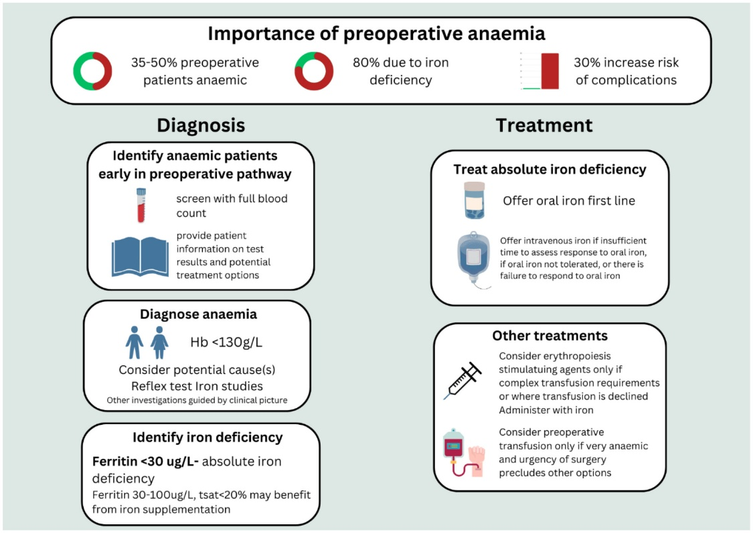

1. **Shander A, Corwin HL, Meier J, Auerbach M, Bisbe E, Blitz J, Erhard J, Faraoni D, Farmer SL, Frank SM, Girelli D, Hall T, Hardy JF, Hofmann A, Lee CK, Leung TW, Ozawa S, Sathar J, Spahn DR, Torres R, Warner MA, Muñoz M. Recommendations From the International Consensus Conference on Anemia Management in Surgical Patients (ICCAMS). Ann Surg. 2023 Apr 1;277(4):581-590. doi: 10.1097/SLA.0000000000005721. Epub 2022 Sep 21. PMID: 36134567; PMCID: PMC9994846.**

Abstract: Background: Perioperative anemia has been associated with increased risk of red blood cell transfusion and increased morbidity and mortality after surgery. The optimal approach to the diagnosis and management of perioperative anemia is not fully established. Objective: To develop consensus recommendations for anemia management in surgical patients. Methods: An international expert panel reviewed the current evidence and developed recommendations using modified RAND Delphi methodology. Results: The panel recommends that all patients except those undergoing minor procedures be screened for anemia before surgery. Appropriate therapy for anemia should be guided by an accurate diagnosis of the etiology. The need to proceed with surgery in some patients with anemia is expected to persist. However, early identification and effective treatment of anemia has the potential to reduce the risks associated with surgery and improve clinical outcomes. As with preoperative anemia, postoperative anemia should be treated in the perioperative period.

Conclusions: Early identification and effective treatment of anemia has the potential to improve clinical outcomes in surgical patients.

1. **Munting, K. E., & Klein, A. A. (2019). Optimisation of pre-operative anaemia in patients before elective major surgery – why, who, when and how? Anaesthesia, 74(S1), 49–57.** [**https://doi.org/10.1111/anae.14466**](https://doi.org/10.1111/anae.14466)

Anaemia in surgical patients is a common and serious problem; around 40% of patients presenting for major surgery are anaemic. Patients with pre-operative anaemia have significantly higher rates of morbidity and mortality and are likely to be transfused red cells. In addition, red cell transfusions are independently associated with worse outcomes. Pre-optimisation of anaemia in surgical patients leads to higher pre-operative haemoglobin concentrations and less need for transfusion. Patients undergoing major surgery (defined as blood loss > 500 ml expected or possible) should be optimised if their haemoglobin concentration is less than 130 g.l−1 on screening. Detection of anaemia should follow listing for surgery as soon as possible to allow enough time for optimisation. The most common cause of pre-operative anaemia is iron deficiency, which can be treated with iron therapy. Iron clinics should be set up in either primary or secondary care to allow for optimal treatment. In this review, we present literature supporting the optimisation of pre-operative anaemia and propose a treatment algorithm.

Authors Conclusions: Anemia before major surgery has increased risk of morbidity and mortality, and there’s good evidence that iron therapy in the preoperative period increases Hb concentration and reduces need for transfusions; however, no definitive trials have been published that show an impact on morbidity and/or mortality. However, many national organizations recommend active treatment of IDA with iron.

Both

1. **Greenberg JA, Zwiep TM, Sadek J, Malcolm JC, Mullen KA, McIsaac DI, Musselman RP, Moloo H. Clinical practice guideline: evidence, recommendations and algorithm for the preoperative optimization of anemia, hyperglycemia and smoking. Can J Surg. 2021 Oct;64(5):E491-E509. doi: 10.1503/cjs.011519. Erratum in: Can J Surg. 2021 Nov 18;64(6):E619. doi: 10.1503/cjs.019421. PMID: 34598927; PMCID: PMC8526150.**

**Abstract**: Preoperative optimization has not been explored comprehensively in the surgical literature, as this responsibility has often been divided among surgery, anesthesia and medicine. We developed an evidence-based clinical practice guideline to summarize existing evidence and present diagnostic and treatment algorithms for use by surgeons caring for patients scheduled to undergo major elective surgery. We focus on 3 common comorbid conditions seen across surgical specialties — anemia, hyperglycemia and smoking — as these conditions increase complication rates in patients undergoing major surgery and can be optimized successfully as soon as 6–8 weeks before surgery. With the ability to address these conditions earlier in the patient journey, surgeons can positively affect patient outcomes. The aim of this guideline is to bring optimization in the preoperative period under the existing umbrella of evidence-based surgical care.

Includes a couple algorithms:

**Glycemic Status**

